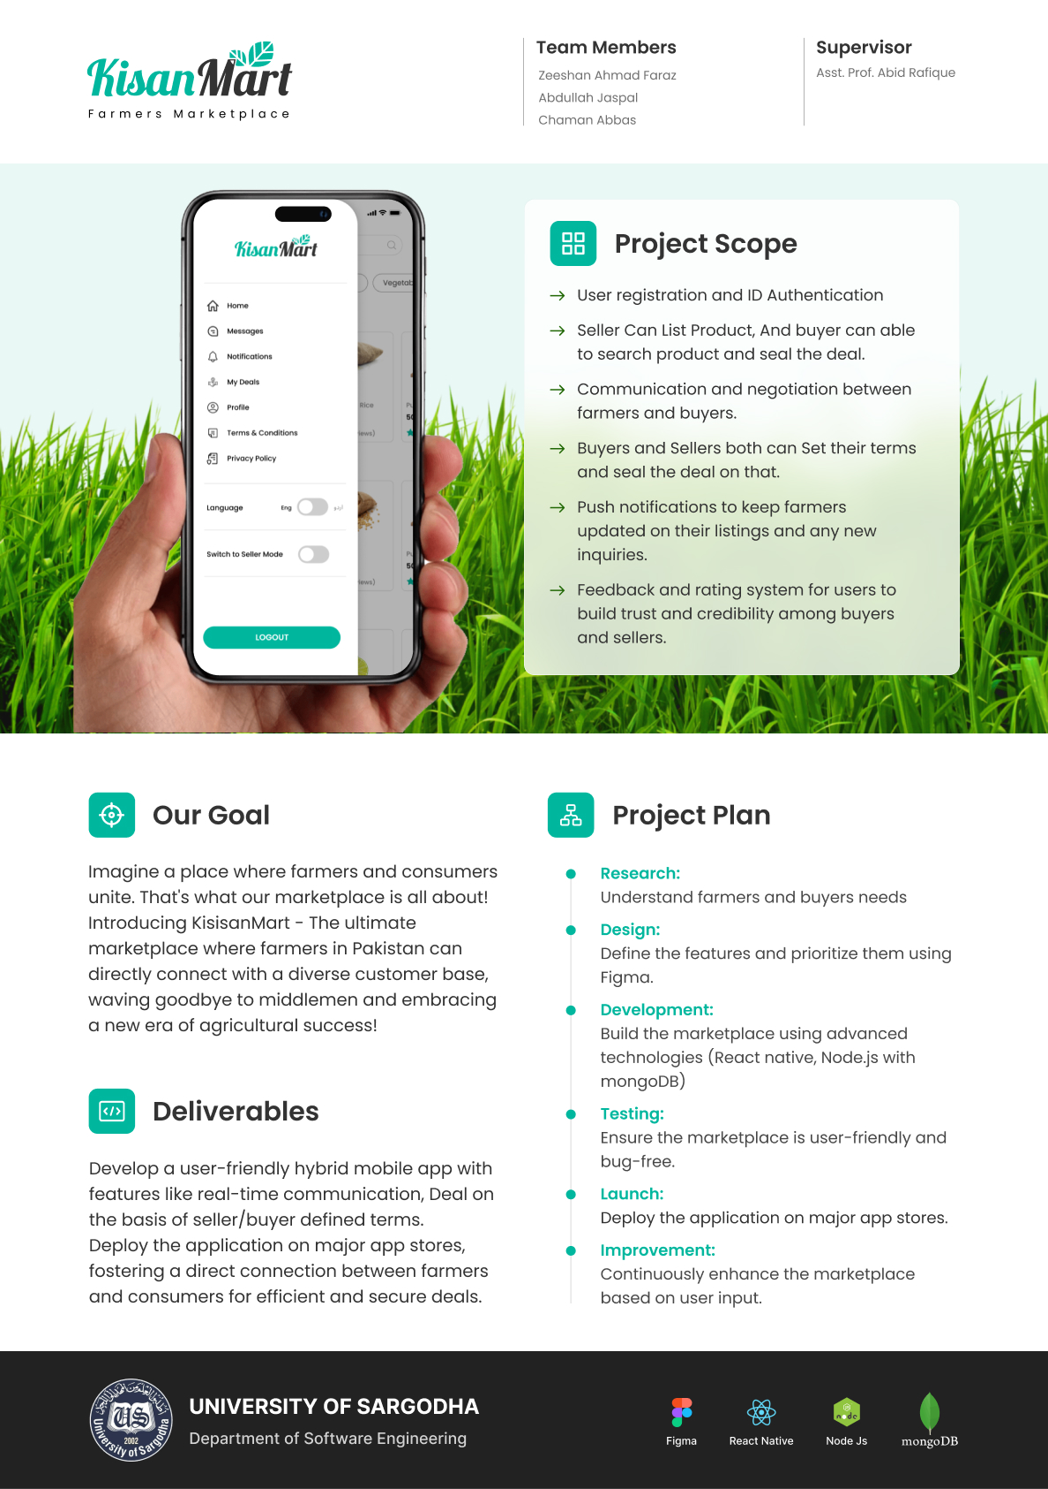

**KisanMart**

**(Farmer’s Marketplace):**

Our Project aims to address the challenges commonly faced by farmers and consumers in traditional marketplaces. We propose an online platform where farmers can directly sell their produce to consumers. This eliminates the need for intermediaries, ensuring fair prices for farmers and access to fresh and locally sourced products for consumers. The goal is to create a convenient and efficient way for farmers to connect with customers and promote sustainable agriculture. It's an exciting initiative that supports local farmers and provides consumers with high-quality, farm-fresh products. We'll put in our best to implement the planned features, but we'll also remain flexible to adapt and make adjustments as needed during real-time execution. We'll follow an agile approach to ensure the best possible outcome.

## 

## **Project Manager:**

Mr. Fahad Maqbool

## **Project Supervisor:**

Mr. Abid Rafiq

## **Project category:**

Mobile application for android and ios.

## **Project Members:**

**1. Chaman Abbas**

**SE department**

[**chaman.devv@gmail.com**](mailto:chaman.devv@gmail.com)

**2.Abdullah**

**SE department**

[**Abdullahafzal4444@gmail.com**](mailto:Abdullahafzal4444@gmail.com)

**3.Zeeshan Ahmad Faraz**

**SE department**

**zee47260@gmail.com**